

Course Name
Computer Programming Lab
Lab Title
Open Ended Lab
Name | Registration Number | Lab #
Muhammad Hamzah Iqbal | F24604018
Date | Instructor’s Name | Instructor’s Signature
17/4/2024 | LE Ayesha Ashfaque

Task 1: Division Calculator

Write a program that asks the user to enter two numbers and calculates their division.
Handle the ZeroDivisionError exception if the user enters 0 as the denominator.
Display an appropriate error message and ask the user to enter a non-zero denominator.

Code:

print("Division Calculator")
a=float(input("Enter a number : "))
b=float(input("Enter a number(Enter non-zero digit) : "))

if b==0:
print("Error,Sorry invalid input")

else:
c=a/b
c=round(c,3)
print(f"Your answer after dividing a and b : {c}")

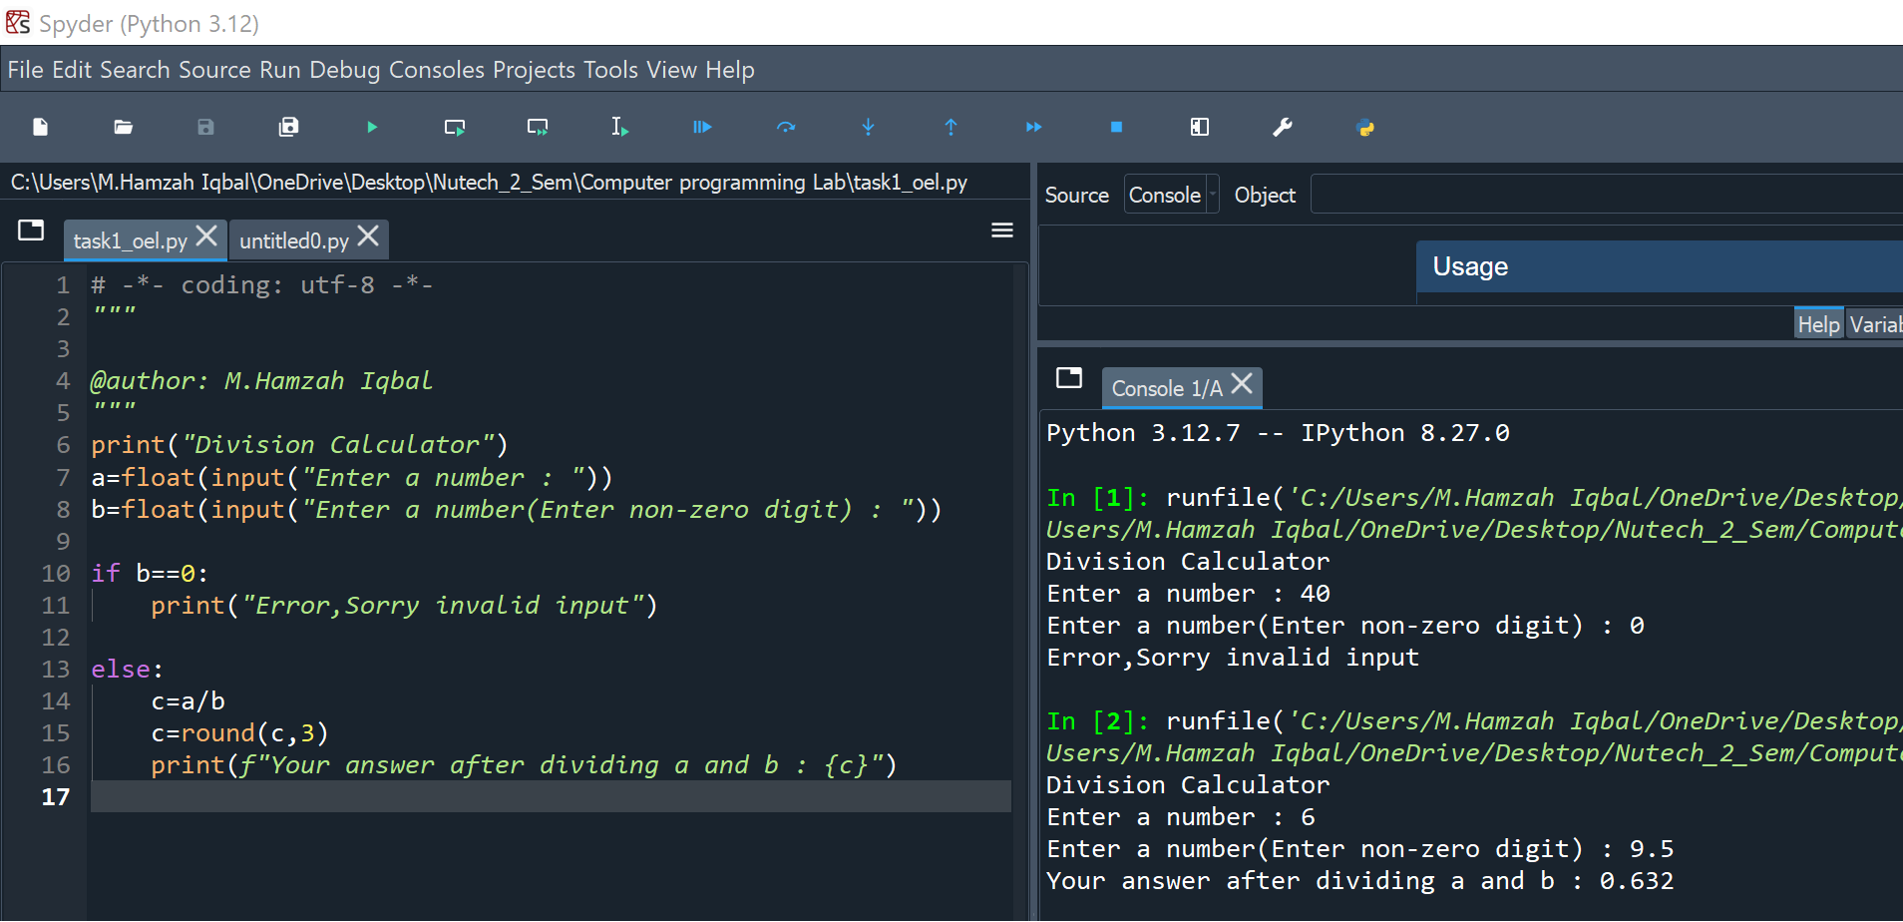

Figure 1 Input and Output

Task 2: Integer Input

Write a program that asks the user to enter an integer.
Handle the ValueError exception if the user enters something other than an integer.
Display an appropriate error message and ask the user to enter a valid integer.

Code:

def get_integer_input():
while True:
try:
user_input = int(input("Please enter an integer: "))
print(f"You entered the integer: {user_input}")
break
except ValueError:
print("That's not a valid integer. Please try again.")

get_integer_input()
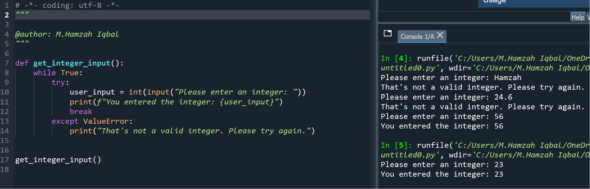
Figure 2 Input and Ouput

Towers of Hanoi:

Code:
def tower_of_hanoi(n, source, destination, helper):
if n == 1:
print(f"Move disk 1 from {source} to {destination}")
else:
tower_of_hanoi(n - 1, source, helper, destination)
print(f"Move disk {n} from {source} to {destination}")
tower_of_hanoi(n - 1, helper, destination, source)

def main():
while True:
try:
n = int(input("Enter the number of disks (positive integer): "))
if n > 0:
tower_of_hanoi(n, 'A', 'C', 'B')
break
else:
print("Please enter a positive integer.")
except ValueError:
print("Invalid input. Please enter a valid integer.")

# Execute the main function
main()

